# Expected Essay Topic: **Global Energy Crunch and Pakistan**

# Introduction:

**(Grabber 1)** Over the past few months, the world has entered into an energy crunch. The benchmark price of a barrel of crude oil is up more than 25 percent from its August low. In Asia, natural-gas prices [are approaching an all-time high](https://www.argusmedia.com/en/news/2260019-asian-spot-lng-prices-poised-to-hit-new-high). The risk of a spillover is high: China, for instance, is not able to secure enough coal to run its mighty power plants, so it has implemented [severe cutbacks and periodic blackouts](https://www.reuters.com/world/china/what-is-behind-chinas-power-crunch-2021-09-27/). In response, factories have shut down and production lines have slowed, which is worsening shortages of goods and commodities. One of those commodities is [processed silicon](https://www.caixinglobal.com/2021-09-30/chinas-solar-panel-makers-may-be-next-victim-of-coal-starved-power-grid-101782544.html), which is getting more expensive—which, finally, is driving up the cost of [solar panels](https://www.theatlantic.com/science/archive/2021/06/why-the-us-doesnt-really-make-solar-panels-anymore-industrial-policy/619213/). It is an irony of our incomplete, abortive energy transition that a shortage of Chinese coal can increase the price of solar panels in America…

**(Grabber 2)** Over the past couple of decades, governments and companies have built the global energy system around natural gas almost without a second thought; it was the cheapest fuel, and easy to integrate into existing systems. Therefore, its share of energy production continued to grow. Now they are running into its problems for the first time—its high costs, unreliability, and dependence on just-in-time systems to deliver it just in time. Governments and companies have set the system up such that natural gas is the world’s indispensable swing fuel, available to fill in the gap in an emergency…

**(Grabber 3)** Power shortages are turning out streetlights and shutting down factories in China. The poor in Brazil are choosing between paying for food or electricity. German corn and wheat farmers can't find fertilizer, made using natural gas. Fears are rising that Europe will have to ration electricity if it's a cold winter. The world is gripped by an energy crunch — a fierce squeeze on some of the key markets for natural gas, oil and other fuels that keep the global economy running and the lights and heat on in homes. Heading into winter, that has meant higher utility bills, more expensive products and growing concern about how energy-consuming Europe and China will recover from the COVID-19 pandemic…

# Global Energy Security

The International Energy Agency defines energy security as the uninterrupted availability of energy sources at an affordable price.

### How is Global Energy Security being threatened in the world?

World will see another global energy security threat due to Russia Ukraine War after the World War II. But at that time, the Allies (UK, US and Soviet Union) had the major control over oil reserves countries including the middle east oil refineries and US, UK oil production department and boards.

### Russia’s strategy to contain Europe through blocking its gas and oil supply

* Russian announcement to block the gas supply to Germany through Nord Stream 1 pipeline to just 20 percent in coming winter.
* Nord Stream 2 could heat **26 million German homes** in winter with about 55 billion cubic meters of gas are to be delivered from Russia to Germany through the **Baltic Sea** every year.
* Russia’s involvement through **Gazprom** in **Trans-Saharan Gas Pipeline Project** to delay its production time.
* Russia supplied around **40**% of Europe’s natural gas before the war, but that has dropped to about 15%, sending prices through the roof and straining energy-intensive industries.
* **Coface** estimates at least **1.5-percentage** point of additional inflation in 2022, which would erode household consumption, and, together with the expected fall in **business investment** and **exports**, **lower GDP growth** by approximately **one percentage point**.

### US and Europe seek to deprive Russia of its Oil and Gas income

* The **Netherlands**, for example, can pump billions of cubic meters of extra natural gas across Europe by increasing production at the **Groningen gas field**. Bewilderingly, however, it is still planning to take the entire operation offline next year over the risk of minor earthquakes in the surrounding area and some pushback from environmentalists. **Germany** can also increase its future capacity to supply energy simply by extending the lifespan of its nuclear power plants that are meant to come offline at the end of the year.
* The US sent nearly three quarters of all its liquefied natural gas to Europe in the first four months of 2022, up from one third last year.

### Russia’s war is helping Qatar in boosting its influence over global energy flows

* **QatarEnergy**, its state-owned gas producer, has in recent weeks announced joint-venture agreements with five of the world’s biggest international oil companies to develop a vast **$29bn** project known as **North Field East**.   
  The project aims to increase Qatar’s annual export capacity from **77mn tonnes to 110mn tonnes by 2026**, helping it to overtake Australia as the second-biggest producer of the fuel behind the US.
* The jump in demand for non-Russian gas is creating a new landscape. “Qatar lost its prime image after the [US] shale revolution but now it has the opportunity to be back on the international scene, both as an important player in gas markets and also by being able to score political points through improved relations with the west.”
* A second phase called **North Field South** could increase its export capacity further to **126mn** tonnes a year by 2027.
* QatarEnergy aims to reduce the carbon intensity of its LNG facilities by **35 per cent** by **2035** through carbon capture technology to ensure a market for its gas even if its customers do cut their emissions to net **zero** between now and **2050**.

### Trans-Saharan Gas Pipeline – A warm light for European homes

* With Niger seeking to improve electricity access and ensure energy affordability through increased exploitation of gas, the TSGP initiative will be a game changer.  The pipeline will enable up to **30 billion cubic meters** of natural gas to be traded yearly enhancing regional and international energy trade, enabling Niger to expand the role of natural gas in its energy mix and address energy poverty through this **US $13 billion** TSGP project.

### Egypt and Israel response to European call for immediate relief

* Egypt’s extensive natural gas facilities in the Mediterranean have stood largely inactive since the country’s 2011 uprising that toppled longtime autocrat Hosni Mubarak.
* Egypt, with recent major discoveries, exported **8.9 billion cubic meters** of natural gas in 2021 and **4.7 billion cubic meters** until May this year, according to Refinitiv Eikon, a global provider of financial and market data. Most of the exports, however, go to Asian markets.
* The European official said the EU will provide **100 million euros** (around $105 million) for “immediate relief” to help Egypt, the world’s biggest wheat importer, address food insecurity in the short term. “This will hopefully help to increase the grain storage capacity and will provide finances for rural businesses and farmers” in Egypt.
* According to the deal, the Israeli gas will be brought via pipeline to **Egypt’s LNG terminal** in the **Mediterranean Sea** before being transported by tanker to European shores, Israel’s Energy Ministry said.
* Israel has two operational gas fields off its Mediterranean coast containing an estimated **690 billion cubic meters of natural gas** combined and a third offshore rig is in the works. It has already signed gas export agreements with neighboring Egypt and Jordan.

## Russia’s first dose to Asia for increasing its export of Oil and Gas

* [According to various estimates](https://www.bloomberg.com/news/articles/2022-03-31/russia-offers-oil-to-india-at-steep-discount-to-pre-war-price), discount may be as high as **$25-35**[**per barrel**](https://fortune.com/2022/05/20/russia-ural-oil-price-china-india-buying-discount/), which attracts profit-minded refiners that have already significantly boosted their margins and countries that are experiencing economic difficulties and cannot afford to purchase oil at the high official price.
  + India and china increased its import without any fear and hesitation from the West. Remember, India is a part of QUAD.
* Furthermore, shaping the direction to Asia for exports is also threatening the Gulf states exports which is further creating a bloc for global interests.

## Implications of Ukraine War over global inflation

* The Conflict threatens to squeeze energy and commodities markets:
  + Russia is the world’s 3rd oil producer, the 2nd natural gas producer and among the top 5 producers of steel, nickel and aluminum. It is also the largest wheat exporter in the world (almost 20% of global trade). On its side, Ukraine is a key producer of corn (6th largest), wheat (7th), sunflowers (1st), and is amongst the top ten producers for sugar beet, barley, soya and rapeseed.
* No region will be left from soaring imported inflation and global trade disruptions
  + The **International Monetary Fund** predicts the U.S. inflation rate will reach **7.7%** this year and **5.3%** in the euro zone.
  + World Bank lowered its global growth forecast for 2022 by nearly a full percentage point, from **4.1% to 3.2%,** citing the pressure that Russia’s invasion of Ukraine has placed on the global economy.
* According to FAO, food prices increased to 34% and crude oil prices to 60% in 2022.
* 36 countries in the world import more than 50% of their wheat from Russia and Ukraine. After the war, wheat and maize prices goes above 30%.

## Recommendations

* Call on all countries to keep engaging in multilateralzy fora to address urgent global food, energy and financial issues. Delays in collective action will exacerbate already troubling prospects for the world economy.
* Call on all countries and stakeholders to recognize that the very nature of increasingly common global shocks is such that countries are not individually responsible, and that therefore solutions must be based on global, and not solely country-based, risk.
* Make immediate and efficient use of all the existing mechanisms to address both, the countries directly suffering from the war (Ukraine and the neighboring countries) but also, as shown in the analysis, the global consequences of the war in developing countries.
* Call not only on countries, but also on the private, civil society and the philanthropic sectors to help the most vulnerable populations around the world and to be proactive actors in the pursuit of coordinated solutions. Fragmented interventions will not lead to the best results.
* **German Takes New Steps to Tackle the Energy Crisis**

https://www.weforum.org/agenda/2022/08/energy-crisis-germany-europe?utm_source=facebook&utm_medium=social_scheduler&utm_term=Energy&utm_content=28/08/2022+01:00&fbclid=IwAR3Wq6xNKuLQl2VDUvQEIvaR7kscyLCcJfpAC09s6JAwqJM_49JQ-2YKGv4

# General Information

* The Nord Stream 1 pipeline stretches 1,200km (745 miles) under the Baltic Sea from the Russian coast near St Petersburg to north-eastern Germany. It opened in 2011, and can send a maximum of 170m cubic meters of gas per day from Russia to Germany.

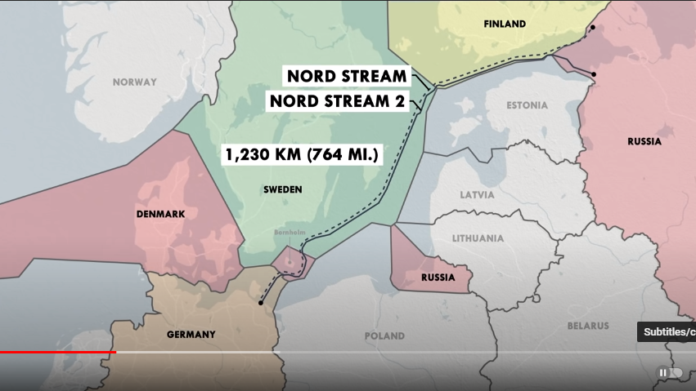

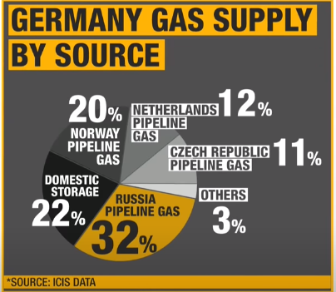

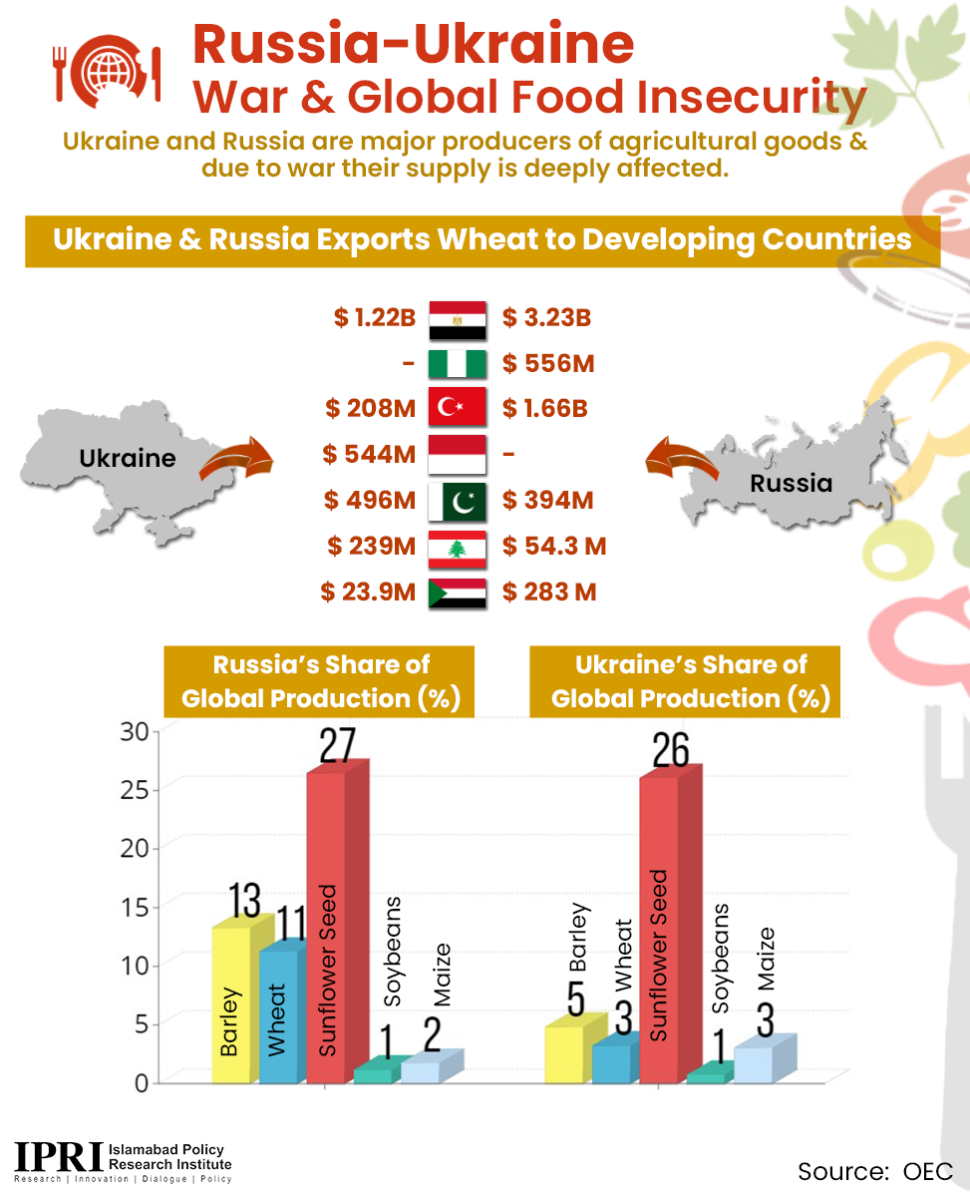

* Qatar discovered the North Field, one of the world’s largest gas reserves which it shares with Iran, in the Gulf north-east of the peninsula in 1971. It delivered its first LNG cargo to Japan in 1996. By 2010, Qatar was the biggest LNG provider in the world, producing 55mn tonnes that year, according to Wood Mackenzie.
* Nigeria, Niger and Algeria are among the least secured areas in the region because of various active terrorist movements that destabilize the all technical processes and construction of gas pipelines across Africa. That, however, the Trans-Saharan gas pipeline is still seen as an opportunity to diversify the gas supplies to the European Union.

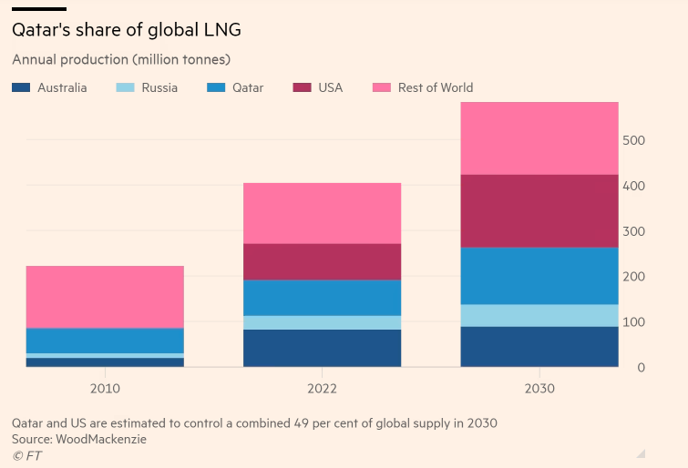

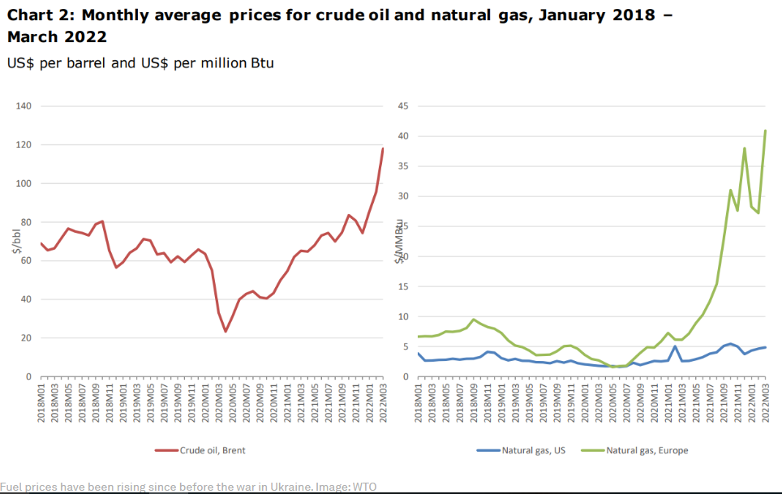

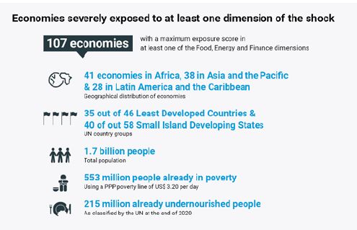

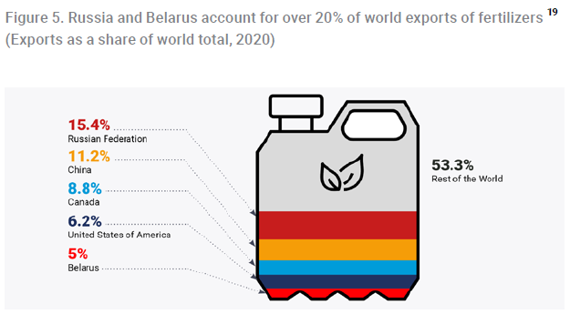

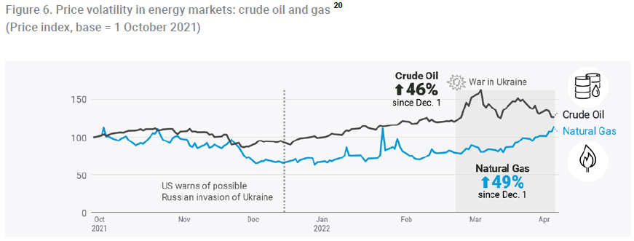

In March 2022, the United Nations Secretary-General announced the establishment of a **Global Crisis**

**Response Group** on Food, Energy and Finance facilitated by the UN Secretariat to coordinate the global

response to the worldwide impacts of the war in Ukraine on global food, energy and finance systems.

# Global Energy Crisis’ Ramifications on Pakistan

* Pakistan raised electricity prices to match rising generation costs amid a global energy crisis.
* Inflation last month (in July) reached **21.3%**, driven mainly by rising food costs, and the country also faces fast-depleting foreign reserves, a depreciating currency and widening current account deficit.
* Higher energy imports have hit the economy as the country struggles to boost foreign exchange. The rupee has lost **20** **percent** of its value in 2022. Reserves have fallen to as low as **$9.3 billion**, hardly enough to pay for **45 days** of imports.
* Energy shortage has a significant effect on businesses in developing countries. As a necessity of life, energy has a significant impact on economic growth and has become the reason for social uplift.  However, an acute energy crisis is hampering businesses’ profitability and productivity; thus, impeding local economic activity.

# Pakistan’s Interminable Energy Crisis: A Public Policy Dilemma OR Circular Debt Continues to Plague Energy Crisis

## Why did Circular Debt Emerge?

* End-consumer tariffs were insufficient to recover the rising costs of power generation, and the government, due to fiscal constraints, was not fully compensating PEPCO against the resulting losses. tariffs for power generation companies are governed by power purchase agreements,7 which define the base tariff for power generation as well as the process for subsequent adjustments. Although NEPRA determines their tariffs, the government has a key role as these tariffs become legally binding only after being notified by the government. This severely limits NEPRA’s operational independence.
* During November 2003 to February 2007, end-consumer tariffs remained unchanged. This was because NEPRA did not allow any revision in tariffs despite requests from DISCOs
* PEPCO has also been facing problems in recovering dues from its consumers. For instance, recovery of dues from FATA is very low. Similarly, a number of private individuals do not pay their monthly electricity bills.

## Three-pronged challenges in Pakistan’s Power Sector:

### **Demand/Supply Gap**

In 2022, the country has an average gap between supply and demand of about 5,000 megawatts, which is leading to around 10 to 12 hours of load shedding.

### **Affordability**

Pakistan’s electricity generation cost rises to 13.15 kilowatt per hour in May 2022 as compared to 5.7 kWh in May 2021. The increase comes mainly due to price hike in the cost of generation for furnace oil (FO), Re-gasified Liquefied Natural Gas (RLNG), and Coal, which increased by 135 percent, 178 percent, 130 percent respectively, according to **Ismail Iqbal Securities Limited.**

**Case Study**: Electricity-generation costs per unit stand **around Tk 4.48 per unit (kWh)** in FY22 in Bangladesh, which is three-fold less than the average electricity generation costs of Pakistan that stands around **13.15 kWh**.

The answer lies in the energy mix that Pakistan has. If one look at energy mix, one will find that around 64 percent energy is coming from either diesel or residual fuel oil (RFO), furnace oil, or mixed fuel. Because of this burden, and because of the high cost of oil, our cost of production has gone up quite significantly. This is compromising our competitiveness and putting a burden of electricity or energy on the end consumer.

### **Inefficiencies**

Recall the transmission and distribution losses in Pakistan; a **21 to 22** percent loss rate is very high. The biggest chunk in this is the distribution losses, although we can stand to improve transmission losses as well.

Pakistan’s power sector is driven by regulations and opportunistic types of transactions and bureaucracy.

# Power Sector’s Debt Hampering Pakistan’s Economic Sustainability Path

(Economic Survey 2021-22)

**Circular debt of Pakistan at Rs2.467tr**

* **3.8 percent of GDP**
* **5.6 percent of the country’s total debt**

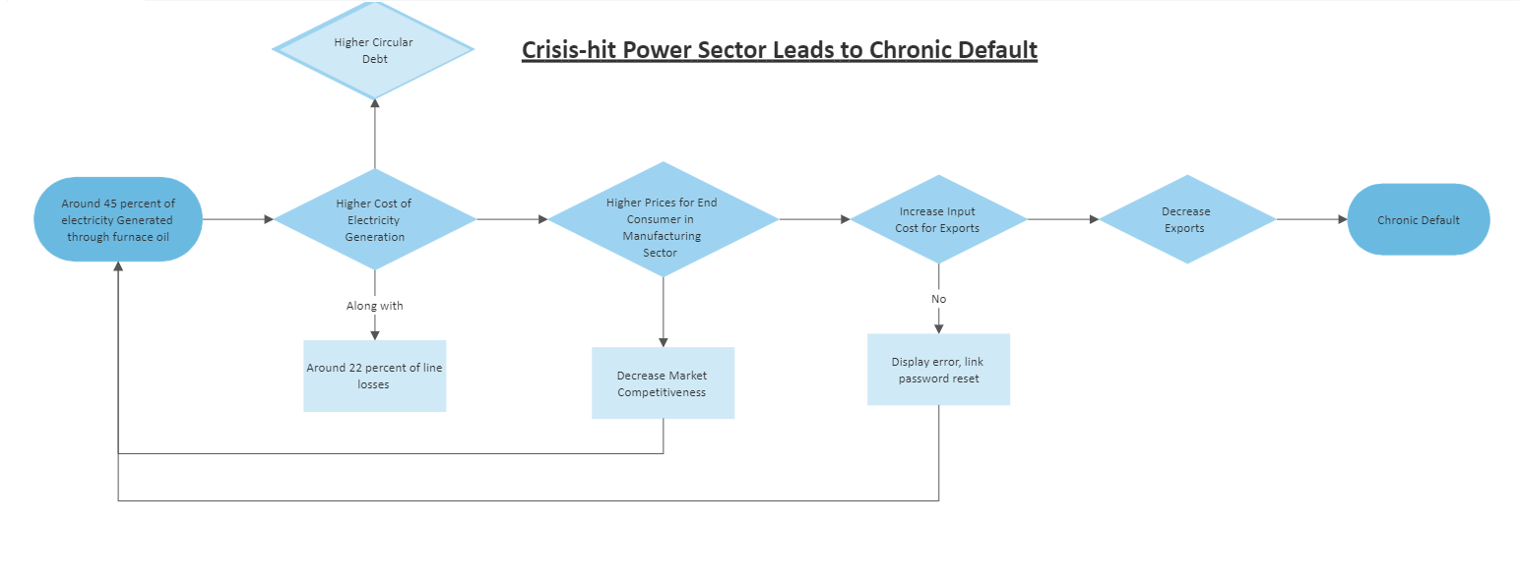

# Power Sector Reforms in Pakistan along with Case Studies

## **Resolution of Circular Debt**

<https://www.atlanticcouncil.org/in-depth-research-reports/issue-brief/transforming-the-power-sector-in-developing-countries-geopolitics-poverty-and-climate-change-in-pakistan/> (for Recommendation Part)

# References:

1. <https://www.thenews.com.pk/print/978592-global-energy-security>
2. <https://www.ft.com/content/eb611a7b-45dd-4eea-ba62-f9fdac68d1d2>
3. <https://www.nytimes.com/2022/05/16/world/middleeast/russia-gas-ukraine-qatar.html>
4. <https://moderndiplomacy.eu/2022/07/06/amid-russia-ukraine-crisis-trans-saharan-gas-pipeline-offers-hope-for-europe/>
5. <https://apnews.com/article/russia-ukraine-africa-business-israel-middle-east-616eb2f2acb9f17537b5fc61dc898d2e>
6. [https://www.coface.com/News-Publications/News/Economic-consequences-of-the-Russia-Ukraine-conflict-Stagflation-ahead#:~:text=On%20the%20day%20the%20invasion,metals%20and%20food%20commodities%20surged.](https://www.coface.com/News-Publications/News/Economic-consequences-of-the-Russia-Ukraine-conflict-Stagflation-ahead%23:~:text=On%20the%20day%20the%20invasion,metals%20and%20food%20commodities%20surged.)
7. <https://www.cnbc.com/2022/04/21/from-food-to-inflation-the-russia-ukraine-war-has-a-global-impact.html>
8. <https://www.weforum.org/agenda/2022/04/ukraine-war-global-trade-risk/>
9. <https://www.mei.edu/publications/war-ukraine-and-new-reality-asian-oil-markets>

# Research Paper:

<https://news.un.org/pages/wp-content/uploads/2022/04/UN-GCRG-Brief-1.pdf>